## [Pattern (Java Platform SE 8 ) - Oracle Help Center](https://www.bing.com/ck/a?!&&p=92a11ca80cc731b4489b798a21e91a647ac17fbf376fb344127947712a2c8ba7JmltdHM9MTczNDM5MzYwMA&ptn=3&ver=2&hsh=4&fclid=0ce60d2d-5a95-60d0-0396-19985bd66108&u=a1aHR0cHM6Ly9kb2NzLm9yYWNsZS5jb20vamF2YXNlLzgvZG9jcy9hcGkvamF2YS91dGlsL3JlZ2V4L1BhdHRlcm4uaHRtbA&ntb=1" \t "https://www.bing.com/_blank)

<https://docs.oracle.com/javase/8/docs/api/java/util/regex/Pattern.html>

## 1.Introduction

Class Pattern

java.lang.Object

java.util.regex.Pattern

All Implemented Interfaces:

Serializable

public final class Pattern

extends Object

implements Serializable

A compiled representation of a regular expression.

正则表达式的编译表示。

A regular expression, specified as a string, must first be compiled into an instance of this class. The resulting pattern can then be used to create a Matcher object that can match arbitrary character sequences against the regular expression. All of the state involved in performing a match resides in the matcher, so many matchers can share the same pattern.

指定为字符串的正则表达式必须首先编译到此类的实例中。然后，生成的模式可用于创建一个[Matcher](https://docs.oracle.com/javase/8/docs/api/java/util/regex/Matcher.html" \o "class in java.util.regex)对象，该对象可以将任意[字符序列](https://docs.oracle.com/javase/8/docs/api/java/lang/CharSequence.html" \o "interface in java.lang)与常规字符序列进行匹配 表达。执行比赛涉及的所有状态都位于 匹配器，很多匹配器可以共享相同的模式。

A typical invocation sequence is thus

典型的调用顺序是

Pattern p = Pattern.compile("a*b");

Matcher m = p.matcher("aaaaab");

boolean b = m.matches();

A matches method is defined by this class as a convenience for when a regular expression is used just once. This method compiles an expression and matches an input sequence against it in a single invocation. The statement

boolean b = Pattern.matches("a*b", "aaaaab");

is equivalent to the three statements above, though for repeated matches it is less efficient since it does not allow the compiled pattern to be reused.

Instances of this class are immutable and are safe for use by multiple concurrent threads. Instances of the Matcher class are not safe for such use.

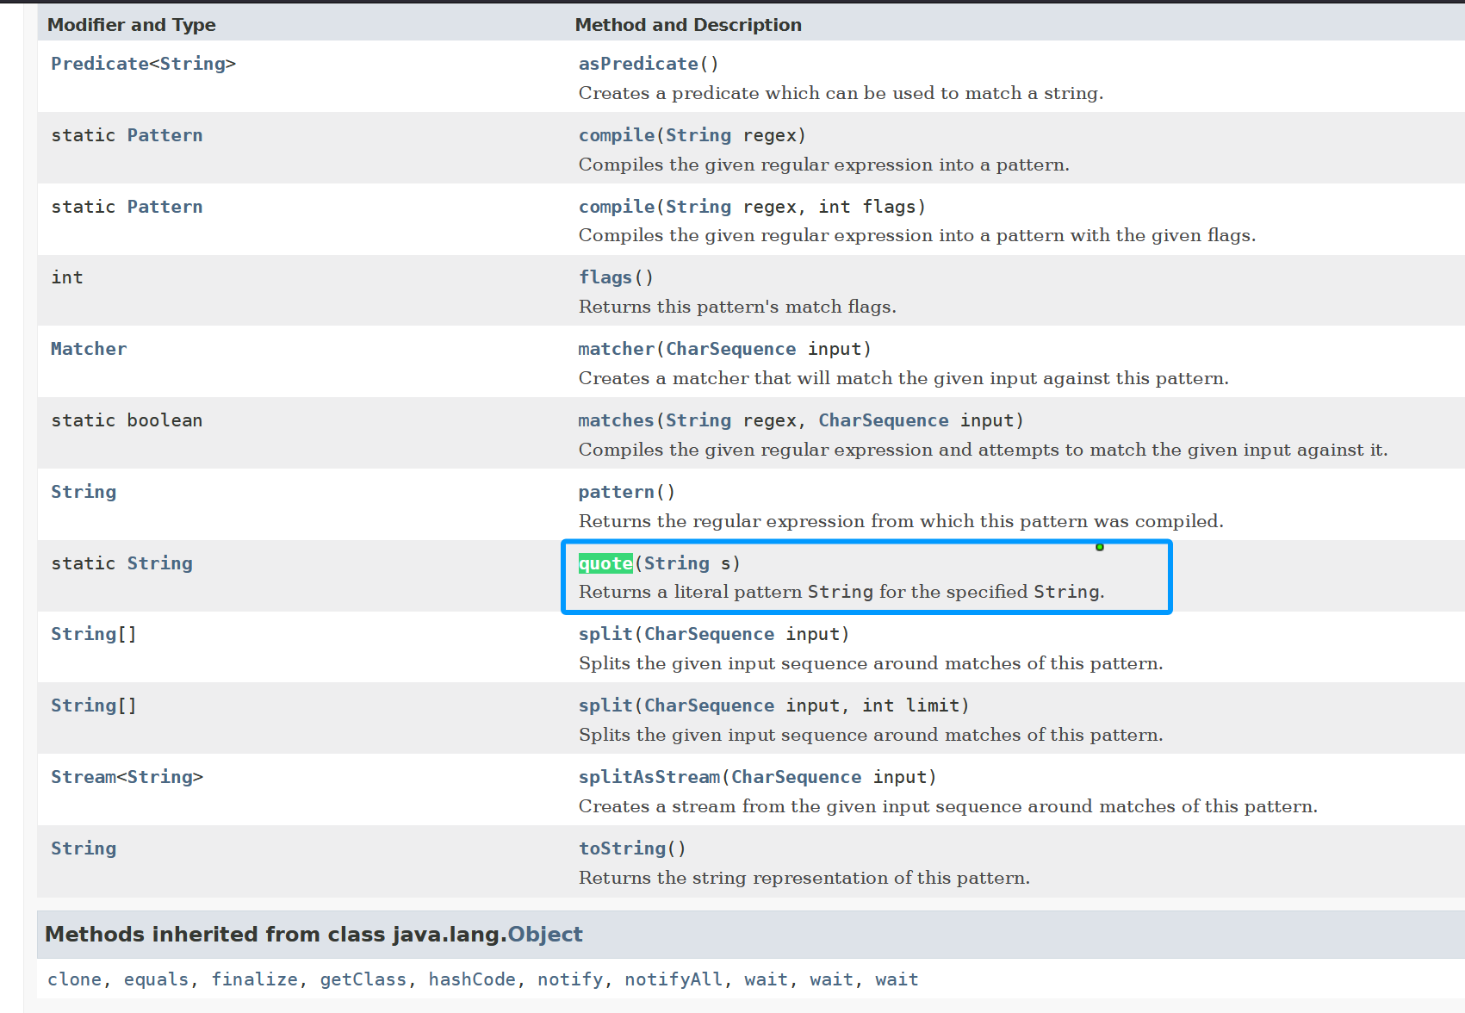

\Q...\E